DETAIL CONNECTIONS –PRINCIPLES

Refers to section: Seamless flooring
Valid from: 2019-11-12 (addendum text for ”ceramic tiles”)
First version: 2005-11-18

Detail connections - principles  To provide the industry's principles for retail connections, the industrial flooring section has brought up this industry recommendation.  The principles cover all the most common details regarding seamless coatings and are a valuable tool for construction, planning, and design. The detail connections are available as images for descriptions and are common industry guidance and principle for performers, contractors and installers. |  | 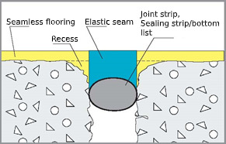  For existing dilatation joint/crack, connection with the elastic joint can be made visible (see also cracks).
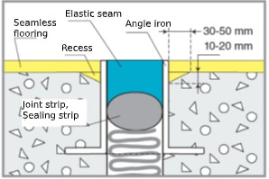  Connection to a new and existing expansion/dilation joint is carried out with a triangular recess towards goods. The elastic sealant should be as wide as deep and placed on a dense bottom material. |  | 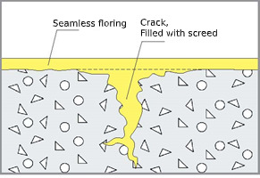  Where applicable, the product supplier recommends that plastering is carried out and a comprehensive seamless floor is laid over cracks. In special cases, with wide cracks, sawing is performed through the floor and joints are made in grooves.
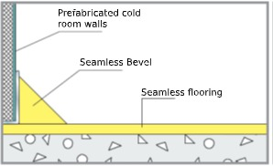  Connection to prefabricated cold room wall.  Bevel: width 20-30 mm, height 20-30 mm. |  | 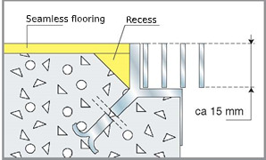  Connections to wells, floor trenches, etc. In concrete castings are carried out with triangular recesses against the castings. Width 20-50 mm, height 10-30 mm.
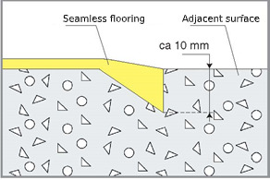  At mid-floor connections, a recess is made so that a smoother transition and reinforcement is obtained. |  | 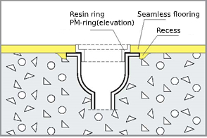  A PM-ring is used at existing wells as elevation, e.g. when changing the surface coating from the plastic mat.
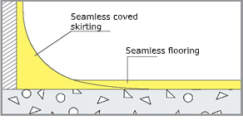  Coved skirting: height 50-200 mm, radius 30 mm. Coved skirting applied before flooring. |  | 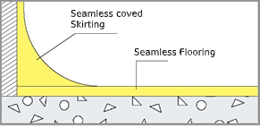  Coved skirting: height 50-200 mm, radius 30 mm. Coved skirting applied after flooring
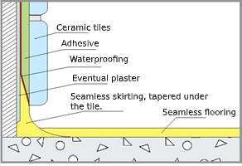  Ceramic tiles on walls,  Skirting design. Ceramic tiles can be applied after the skiting with an overlap on 20-30mm. The thickness of the skirting of the overlap becomes 1-2 mm. |  | 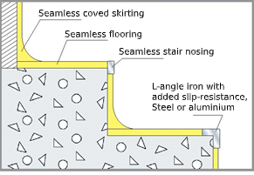  Coating of stairs. ''Exposed Edge'' is provided with stainless steel/aluminum nozzle 50-70 x 5 mm alt. L-iron/profile.
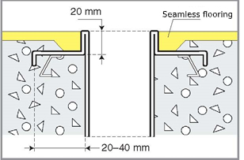  Connection to stainless steel wells, gutters and grease and seperators. |  | 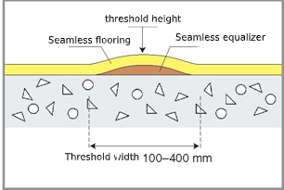  Structure for threshold strips, embankment and water rejection.
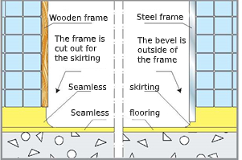  A cut-out and surface-mounted connection around door frames between wet areas. |  | 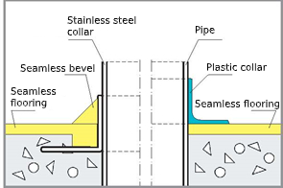  Connection of stainless steel and plastic casing around pipe penetration in concrete floors.

